**Bano Qabil (Web-Development Pt. 2)**

**Assignment # 01 (JavaScript Basics)**

Q1: Reverse a string without using the built-in reverse() method.

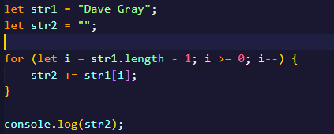

**Output:**

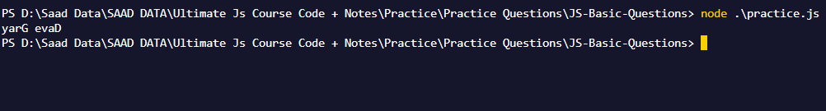

Q2: Count the number of vowels in a given string.

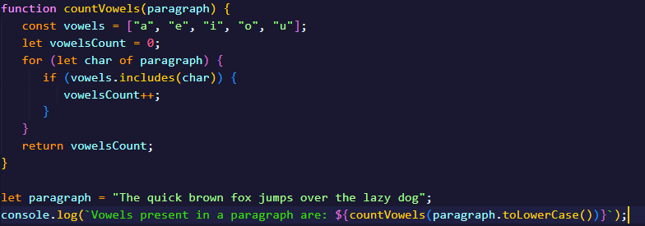

**Output:**



Q3. Convert the first letter of each word in a sentence to uppercase.

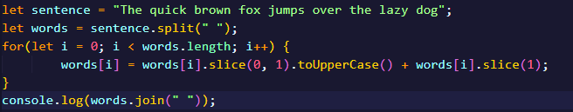

**Output:**



Q4: Check if a string is a palindrome.

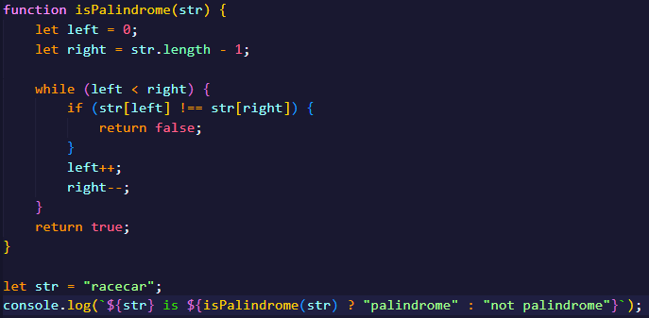

**Output:**



Q5: Find the sum of all positive numbers in an array.

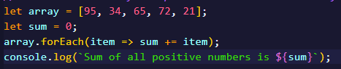

**Output:**

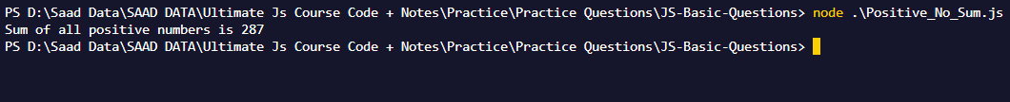

Q6: Find the index of the first occurrence of a specific element in an array.

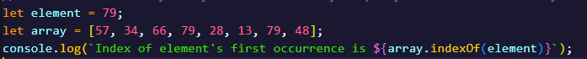

**Output:**



Q7: Remove all duplicates from an array without built-in methods.

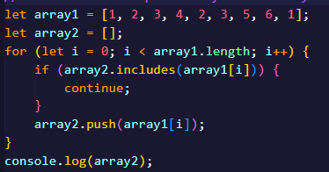

**Output:**



Q8: Sort the array in ascending and descending without built-in methods.

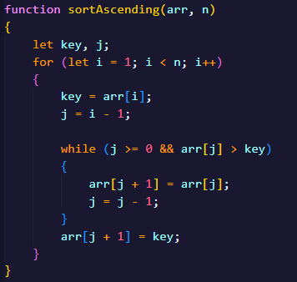

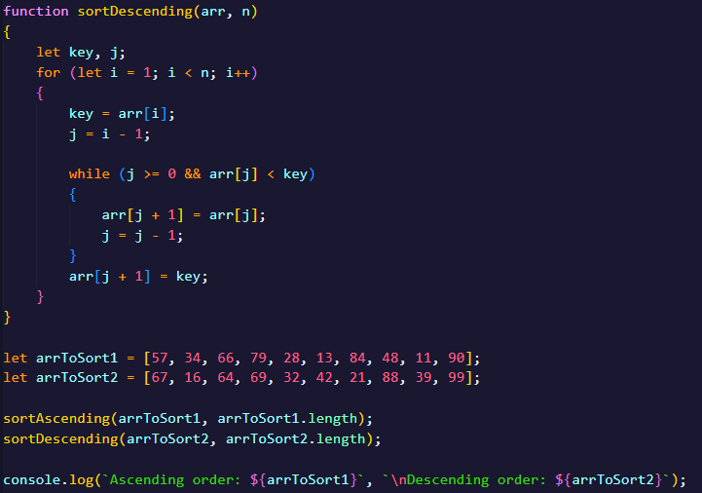

**Output:**



Q9: Print all even numbers between 1 and 20 using a while loop.

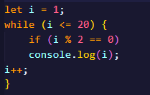

**Output:**

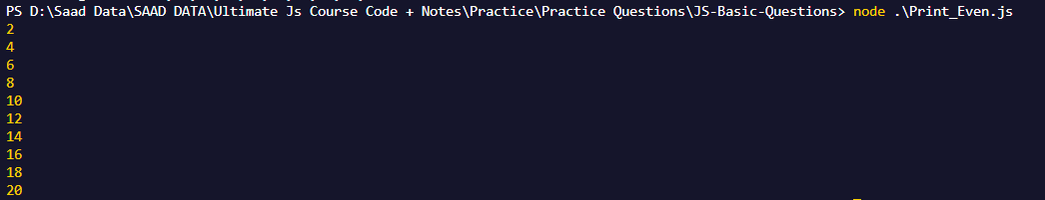

Q10: Calculate the factorial of a number using a do-while loop.

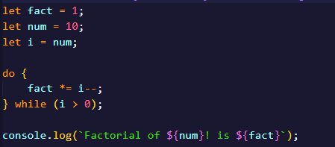

**Output:**



Q11:  Iterate through the properties of an object using a for-in loop.

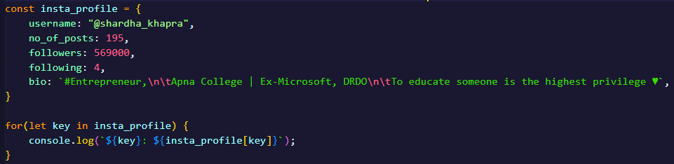

**Output:**

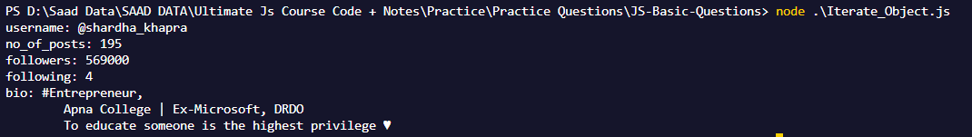

Q12: Loop through an array using a for-of loop and double each element.

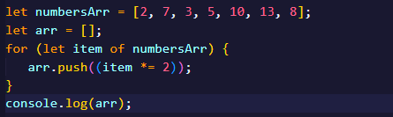

**Output:**

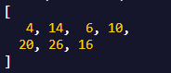

Q13:  Check if a number is even or odd and return a corresponding message.



**Output:**



Q14: Find the maximum of three numbers using nested ternary operators.

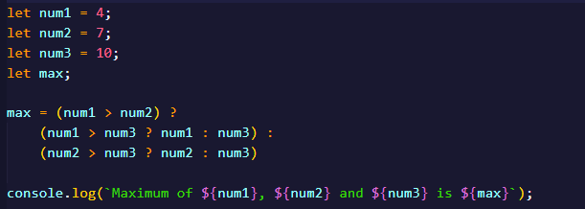

**Output:**



Q15: Determine if a year is a leap year or not.

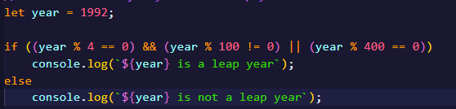

**Output:**



***GitHub Repo Link:***

<https://github.com/Its-SaAdi/Assignment-1_BanoQabil-WD-2>